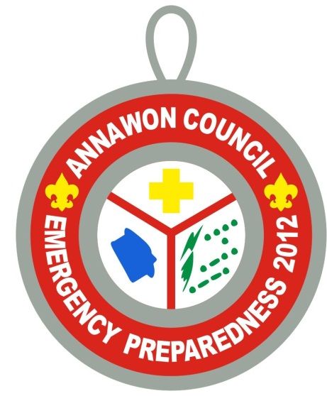The Mansfield and Norton
Emergency Management Agencies
Are Sponsoring
Emergency Preparedness
(Including First Aid Merit Badge)
Merit Badge Instruction & Drill
(max 120 attendees, FIRST CLASS RANK and ABOVE)
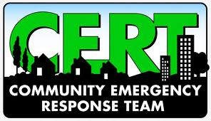OR if you already have EPrep…
Begin training to become a member of your local
Community Emergency Response Team
Search and Rescue, Disaster Preparedness, CERT Organization and Disaster Psychology
Or if Ham Radio is your thing…
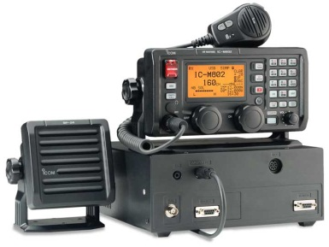Amateur Radio Technician Study Session, Test Prep and Testing (max 25 attendees)
Receive assistance and take the test! Testing fees of $15 are not included and may be made payable at Camp. You must register for Ham Technicians training by April 30 in order to guarantee adequate testing supplies, and to learn prerequisites.
Event held at Camp Norse on June 1-3, 2012. Please register online at www.annawonbsa.org.
$6 per person fee may be paid online (with additional convenience fees), or mailed in or paid at Camp Norse upon check-in. Units should plan on tent camping, limited cabin space available. Individual scouts from troops not attending should contact a neighboring troop to join them for the weekend.

For additional questions, please contact Rick Sitte at scouter-rick@comcast.net.

